1. **Purpose of this Briefing**

The purpose of this briefing is to equip local practitioners to enable them to support children and young people in recognising and disclosing sexual abuse.

This briefing provides practitioners with local and national child sexual abuse research, information, and practical resources to support with this important and often difficult area of work.

**02. Background**

Leicester’s Safeguarding Children Partnership carried out and [published](https://www.lcitylscb.org/media/1981/lcspr-child-c-and-d-final.pdf) a local child safeguarding practice review (LCSPR) which recommended a local initiative to ensure that children feel supported in recognising and disclosing sexual abuse.

7-Minute Briefing: Supporting Disclosure of Child Sexual Abuse (2024)

**03. Barriers to disclosure of child sexual abuse**

Cossar J. et al. (2013) [‘It takes a lot to build trust’ Recognition and Telling: Developing earlier routes to help for children and young people’](https://assets.childrenscommissioner.gov.uk/wpuploads/2017/07/It_takes_a_lot_to_build_trust_FINAL_REPORT.pdf) Office of the Children’s Commissioner for England identified five main barriers to disclosing child sexual abuse, in order of their frequency:

1. An emotional barrier, e.g. shame, embarrassment, not being able to face telling, finding it hard to find/say the words;
2. Worry about the family knowing, loyalty to family and the impact on family members;
3. Thinking their situation was not problematic enough to disclose to others;
4. Threats from the abuser;
5. Fear of not being believed if they were to tell.

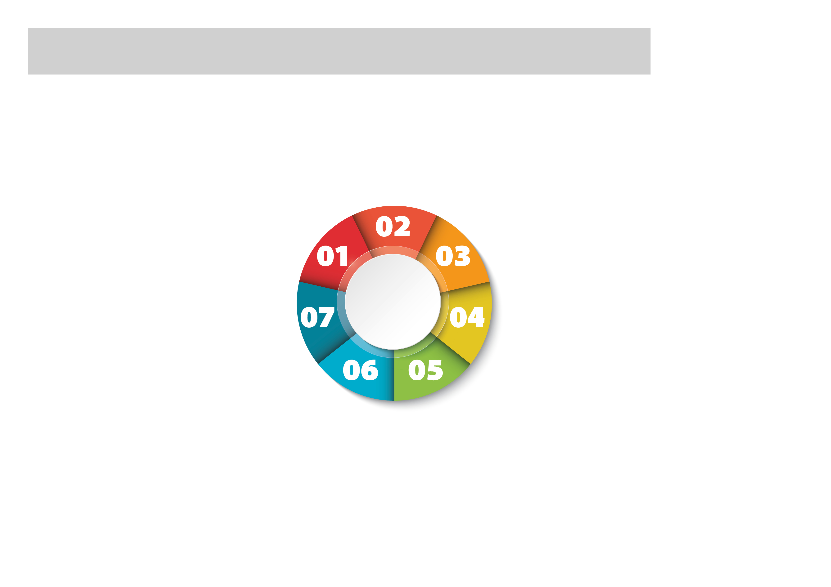

**07. Next steps**

See the next page to read what children and young people have to say.

Go to the last page of this briefing for an overview of free training and resources, including local multi-agency training, local and national resources to support you in practice, and local multi-agency policies and procedures for use in practice.

Read the LCSPR in full, alongside other published reviews and learning briefings on the Safeguarding Children Partnership [website](https://www.lcitylscb.org/learning-from-reviews/).

Explore the published research linked to in this briefing and look out for the upcoming Child Safeguarding Practice Review Panel publication [national review into child sexual abuse within the family environment](https://www.gov.uk/government/publications/national-review-into-child-sexual-abuse-within-the-family-environment-terms-of-reference).

**Supporting Disclosure of Child Sexual Abuse**

**04. Barriers to disclosure of child sexual abuse**

llnock, D. and Miller, P. (2013) [No one noticed, no one heard: a study of disclosures of childhood abuse](https://learning.nspcc.org.uk/research-resources/2013/no-one-noticed-no-one-heard). London: NSPCC describes the childhood experiences of abuse of 60 young men and women and how they disclosed this abuse and sought help. Over 80% of the children in the study had tried to tell someone about the abuse. Disclosure – especially at the time of abuse – is rarely a straightforward process of a child or young person saying they have been abused. Many disclosures were either not recognised or understood, or they were dismissed, played down or ignored; this meant that no action was taken to protect or support the child or young person.

**06 Supporting disclosure of child sexual abuse**

•Some children and young people find it easier to discuss sensitive topics if they can avoid eye contact, e.g. doing activities alongside the adult, in the car, doing the washing up, or going for a walk.

•Face to face disclosure can be difficult – an alternative strategy is to find ways for children and young people to put their concerns in writing to be read when they are not present.

•Research has found that teachers and school-based support are particularly important as people to disclose to [(Cossar J. et al. 2013)](https://assets.childrenscommissioner.gov.uk/wpuploads/2017/07/It_takes_a_lot_to_build_trust_FINAL_REPORT.pdf)

•Do not rely unduly on children disclosing verbally.

•Young people may be encouraged by a sensitive but persistent response from a practitioner conveying care.

•Explain to children and young people how their concerns are likely to be handled, and the outcome, and include them in discussions about when and how to pass on information.

**05. Supporting disclosure of child sexual abuse**

•Be prepared to think the unthinkable: recognise that foster carers or kinship carers might sexually abuse children. Beliefs that placements are settled and perceptions that carers are capable can provide false reassurance that children are safe and well cared for.

•Make time to speak to children and young people alone and outside of the home / placement where they can talk freely and where practitioners can build trusting relationships and understand a child’s lived experience.

•Be aware that if several agencies / practitioners are involved it may give false reassurance children and young people will talk to or disclose concerns to other people.

• Understand that an abusive situation is not always recognised by the child or young person as abuse. Ask and listen to what they are saying including what they are trying to convey through what they say, what they do not say, their behaviour, and their body language.

•Where it is required, use an interpreter.

***

**WHAT CHILDREN AND YOUNG PEOPLE SAY**



“I have to like you first to trust you and I have to trust you to talk to you”

Local Child Sexual Abuse Survivor

“If we tell you, don’t tell our abusers”

Local Child Sexual Abuse Survivor

*******

”I should be able to defend myself. But I can’t I just get so scared. I should have more control over my body so they can’t force me into being aroused, but I don’t know how to stop it”

[Cossar J. et al. (2013, p.38)](https://assets.childrenscommissioner.gov.uk/wpuploads/2017/07/It_takes_a_lot_to_build_trust_FINAL_REPORT.pdf)

“I never told anyone about this as I didn’t think anything was wrong, but I’ve come to realise now”

[Cossar J. et al. (2013, p.42)](https://assets.childrenscommissioner.gov.uk/wpuploads/2017/07/It_takes_a_lot_to_build_trust_FINAL_REPORT.pdf)

“One worker listened to me and when they listened without judgement and with compassion a difference was made. They believed me and they acted upon what I told them”

Local Child Sexual Abuse Survivor

“Listening to the young people you work with isn’t always about the words we say. My actions spoke louder than my words”

Local Child Sexual Abuse Survivor

**NATIONAL RESOURCES**

[Centre of expertise on child sexual abuse](https://www.csacentre.org.uk/) which includes:

[Resources to help education professionals to identify and respond when they have concerns about child sexual abuse or behaviour](https://www.csacentre.org.uk/research-resources/practice-resources/helping-education-settings-identify-and-respond-to-concerns/)

[Signs and indicators template](https://www.csacentre.org.uk/research-resources/practice-resources/signs-and-indicators/)

[Communicating with children](https://www.csacentre.org.uk/research-resources/practice-resources/communicating-with-children/)

**LOCAL RESOURCES**

[‘Was Not Heard’](https://www.youtube.com/watch?v=61zqHXPZdcc) a locally co-produced short film advocating the right of children to be heard and the duty of those working with them to act.

[How will you hear me?](https://www.youtube.com/watch?v=ck5uzeEgSdY) A collection of local short films written by young people exploring their experiences and how they felt they were treated and listened to. The final scripts are performed by young actors.

**LOCAL TRAINING**

Watch the 22 minute recording of [Safeguarding Matters Live](https://www.youtube.com/watch?v=s3CwbX20h5k) held in July 2024 with a focus on Child Sexual Abuse from 51:16 minutes in through to 1:13:25 which focuses on case studies, local and national data, and local and national learning from reviews.

[7-Minute Briefing on Child Sexual Abuse in the family environment](https://lrsb.org.uk/uploads/child-sexual-abuse-in-the-family-environment.pdf?v=1720088450) which includes national and local learning and resources.

**LOCAL TRAINING**

[LLR Safeguarding Children Partnerships Multi-Agency Training](https://www.eventbrite.co.uk/o/llr-safeguarding-children-partnerships-8043549452)

Look out for training such as ‘Following the Breadcrumbs: Understanding and working with disclosures of child sexual abuse’ online training delivered by survivors from [REIGN](https://www.reigncollective.org.uk/), designed for any adult with a role to play in protecting children.

**NATIONAL RESOURCES**

[Child Sexual Abuse Response Pathway:](https://www.csacentre.org.uk/child-sexual-abuse-response-pathway/) An interactive online resource to guide professionals through how they can protect and support children and their families when there are concerns of sexual abuse.

This step-by-step resource is centred on children’s needs, how they are feeling and what they hope will happen.

**LOCAL MULTI-AGENCY POLICIES & PROCEDURES**

Leicester, Leicestershire and Rutland multi-agency [Sexual Abuse procedure](https://llrscb.proceduresonline.com/p_sexual_abuse.html) which includes a flowchart for referring to the East Midlands Children and Young People Sexual Assault Service.

[Child Sexual Abuse in the Family Environment](https://llrscb.proceduresonline.com/files/sexual_abuse.pdf)

**FREE TRAINING & RESOURCES AVAILABLE TO YOU**