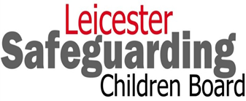
Safeguarding Leicester’s Children Newsletter - January 2019, Issue 7

Welcome to the 7th Issue of the Newsletter

Welcome to 2019 and a Happy New Year to you all. This edition has a number of key elements that we hope you will find interesting and take note of. Please do remember we always welcome feedback on whether these newsletters are useful and how we can find different and more effective ways of sharing multi-agency messages and learning around safeguarding.

We are planning a number of larger events this year beginning with Safeguarding Children with Disabilities – Focus on Assessment on 17th January 2019 (this is a repeat of the event in November 2018). Information on events as they are confirmed should be available on the following link: http://www.lcitylscb.org/lscb-learning-development/training-resources/upcoming-training-events/.

This issue covers:
- Private Fostering
- Youth Service
- Young People’s Project - Jenkins Centre
- Option Chats
- Child Criminal Exploitation (CCE)
- LLR LSCB Neglect Toolkit Survey
- LLR LSCB Safeguarding Training and Learning
- Information/Resources

Private Fostering – What do practitioners need to do?
Anyone working with children and their families may become aware of children who are possibly living in a private fostering arrangement. All practitioners and volunteers therefore, have an important role in being alert to this and in notifying the Local Authority of any possible private fostering arrangement that comes to their attention. In addition, where a practitioner or volunteer is unable to establish or has any doubt whether the arrangement has already been notified to the local authority or where they have any doubts about whether a child’s carers are their parents they should check this with the local authority.

What is Private Fostering?
A private fostering arrangement is one that is made without the involvement of the Local Authority to look after a child under the age of 16 (or under 18 if disabled) by someone other than a parent or close relative, for 28 days or more and can include those living with extended family members. So, this could be a child living with people as stated below:

Private Fostering includes a child living with: | Private Fostering does not include a child living with:
- godparents  - great-grandparents  - great aunts or uncles  - family friends  - step parents where a couple isn't married or in a civil partnership  - cousins  - a host family which is caring for a child from overseas while they are in education here | - brothers  - sisters  - grandparents  - aunts  - uncles  - step parents where a couple is married or in a civil partnership  - mother  - father  - children and young people who are being looked-after by the Local Authority

Private foster carers and those with Parental Responsibility are required to notify the Local Authority’s Children’s Social Care of their intention to privately foster or have a child privately fostered or where a child has been privately fostered in an emergency. This should be done six weeks before the arrangement takes place or immediately if it is unplanned or already happening. This is so the Local Authority can work with private foster carers to keep children safe and also support anyone who is privately fostering. The LSCB has produced information for carers in Bengali, English, Gujarati, Polish, Punjabi, Somali and Urdu, which is available on the LSCB website.

It is the Local Authority’s duty to satisfy itself that the welfare of the children, who are privately fostered within their area, is being safeguarded and promoted. However, the Local Authority can only do so, when it becomes aware of a private fostering arrangement, as there may be such arrangements that have not come to their attention.

Further information on private fostering is available on the LSCB website, which includes links to Somebody Else's Child, the leaflet on information for professionals and LSCB multiagency safeguarding procedure referring to private fostering

Leicester City Youth Service
Leicester City Youth Service finished 2018 on a high! We launched our Youth Power programme in partnership with Leicester City Football Club. This new project sees us being able to double our universal/open access offer across Leicester with the addition on 8 new sessions across West End, Braunstone, Beaumont Leys, Eyres Monsell and Hamilton.

We have also been working closely with our young people to better understand why knife crime has become such an issue within our City. We have formed a youth forum who intend to visit Boroughs in London to learn about gangs and knife crime and find out about initiatives used to reduce them, which they will in turn share with Leicester via the Police knife crime delivery group.

We are also working with young people on a high-profile campaign that we hope will reach all teenagers in Leicester. We are developing our brand and some short films and slogans that can be used on social media. One of our young people also represented our Centres at the annual Police Youth Summit.

Over the coming months we have much more planned including our residential to London in February, our celebration event in March and of course planning for a great summer!

Don’t forget that we are part of the Early Help offer and provide Targeted as well as Universal services, so if you have a young person aged 13 – 19 who would benefit, you can refer them through the Early Help pathway or by calling 0116 4541004.

Please like, follow and share us on Twitter (@YouthLeicester), Facebook (Leicester City Youth Service) and Instagram (Leicester.youth. services).

For more info you can email us at Youth.Services@leicester.gov.uk

Happy New Year from us all at Leicester City Youth Service!
Picut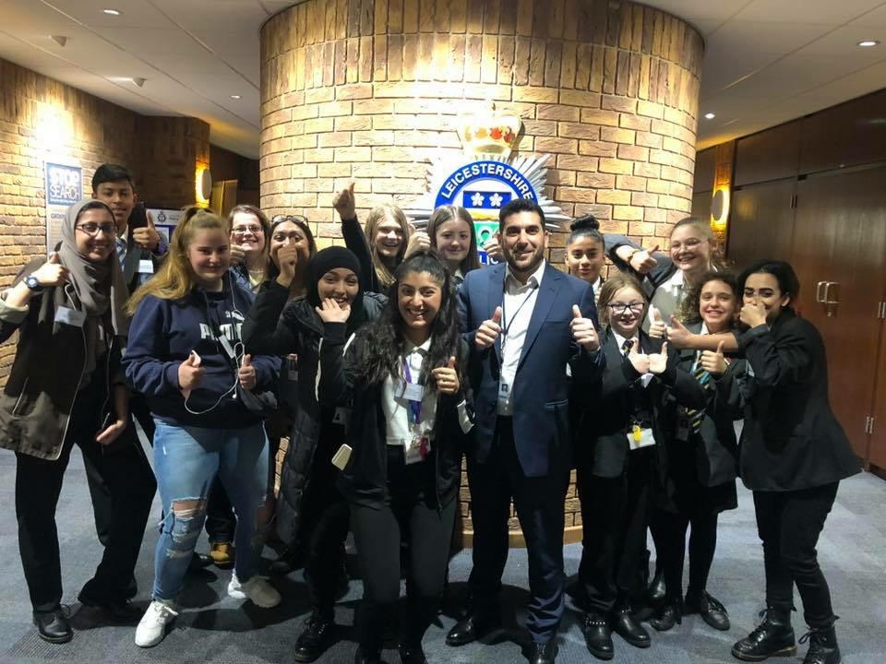

The Young People’s Project at the Jenkins Centre – what do they offer?

At the Jenkins Centre our Young People’s (YP) Project works with Young People in the City, aged 13 to 18 using Adolescent to Parent Violence (APV) or using dating violence, often referred to as Intimate Partner Violence (IPV).
We accept referrals from all professionals and self-referrals (where no agencies are involved). We are happy to discuss any concerns with you prior to making referrals and provide support in completion of the referral form where it is needed.
We are licenced to deliver the Respect Young People’s Programme (RYPP - a parallel programme for the young person and parent(s), delivered over approximately 3 months); are trained in the Respect Toolkit and a range of other approaches which enable us to deliver a bespoke approach where the RYPP is not the suitable programme.
Through the workforce development training accessed via the Council Website you can also access the Child on Parent Abuse (COPA) training delivered by the Jenkins Centre. The training listed includes a range of domestic abuse training delivered by UAVA partners. This is open to CYPFS professionals across Leicester, Leicestershire and Rutland.
The YP Project sits within the Jenkins Centre which also continues to deliver interventions for adults perpetrating domestic abuse, this service includes partner support. For more information, please visit: www.jenkinscentre.org.

Option Chats – did you know about this?

Statistics tell us that on average a person experiences 36 experiences of domestic violence before getting help. The city council’s community safety team want to make it easier for people to get advice or help from the local support service when they need it. With many customer-facing council staff now trained in helping people to access the local support service, a poster campaign inside council venues encourages people to ‘just ask’ for an Options Chat.

Public buildings such as children’s centres, housing offices and customer services are making Options Chats available to help their visitors contact United Against Violence & Abuse (UAVA).

When someone asks for an Options Chat, a trained member of staff can offer to:
• Speak with them privately
• Tell them about the different services available (with a leaflet to help)
• Call or email UAVA to refer the person for help, or in an emergency, contact the police.
If trained staff are not available, any staff member can give a leaflet, and offer the use of a phone and a quiet place for the person to call UAVA.

Read more about the WRONG domestic violence awareness campaign on the Leicester City Council website http://bit.ly/wrongcampaign or follow HowManyTimes on Twitter.

Child Criminal Exploitation (CCE)

As awareness grows about the nature of child exploitation it is important professionals across the partnerships are aware of the many forms it can take. Research has found that the patterns of grooming of children for criminal exploitation are very similar to those of sexual exploitation.

In the past, CSE was often perceived amongst professionals as the victim’s fault, or due to them ‘placing themselves at risk.’ Perceptions are changing but these young people are often still criminalised and perceived as having ‘made a choice’ to take part in illegal activity.

It is important these perceptions do not exist around criminal exploitation by gangs.

Sexual exploitation is used in gangs to:
- Exert power and control over members
- Initiate young people into the gang
- Exchange sexual activity for status or protection
- Entrap rival gang members by exploiting girls and young women
- Inflict sexual assault as a weapon in conflict.

Gangs also exploit children and young people in other ways - boys are particularly at risk of being recruited to be drugs ‘runners’ or to make cash deposits into bank accounts. There is also a growing awareness that debt entrapment is a key threat, with criminals deliberately robbing the young person who is transporting drugs and then holding them while they work to pay it off.

These numbers are not known as we don’t recognise criminal exploitation as vulnerability as easily as CSE but these children are at high risk of violence and intimidation.

The below poster is available for circulation in your organisations, to help raise awareness of gangs and CSE.
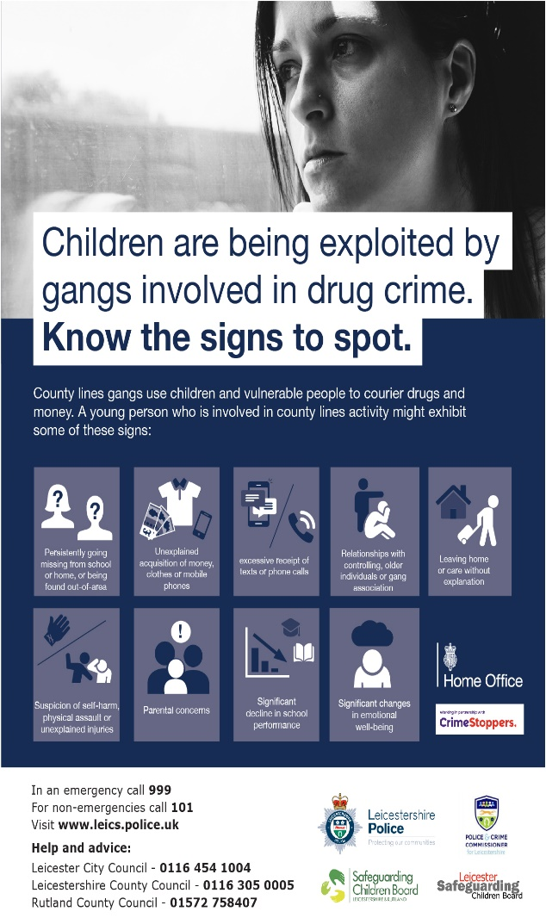

LLR LSCB Neglect Toolkit Survey – what did we find?

In March and April 2018, the third LLR Neglect Toolkit Survey was conducted. It was completed by frontline practitioners and first line managers across the LLR multiagency partnership. This was the third in a series of surveys following the work of partner agency colleagues in the development and the implementation of the LLR LSCB Neglect Toolkit. The results of the survey identified that some agencies were still in the process of embedding this tool despite its launch in July 2016.

Key Findings
- A total of 129 surveys were completed by front line practitioners and first line managers working across Leicester, Leicestershire & Rutland.
- 74 workers covered Leicester City, 63 covered Leicestershire, and 21 covered Rutland (some covered more than one area or all three).
- Agencies were represented from across the multiagency partnership including social care, health, education, the police, and many others.
- 95 said that they were front-line practitioners and 22 said they were first line managers, others included:
Admin, CP/ IRO Chair, Family Intervention Worker, Family Outreach worker, Front line staff, Independent Chair, Link teacher, SEMH Teacher, Safeguarding Lead, Speech and Language Therapist, Support & Assessment Worker, Support and assessment worker, designated safeguarding officer, and youth worker.
- 90% were confident in assessing neglect. 99% were confident in identifying neglect
- When it came to actually using the Neglect Toolkit, 15% were very confident, 48% fairly confident, 9% not very confident and 26% had never used it.
- The majority of those who used the toolkit found it helpful in identifying the types of neglect present in the case. The majority found it helpful in scoring the severity of the neglect.
- Over half said the toolkit was helpful in signposting. Two thirds found it useful in offering support. Three quarters said it helped them identify neglect.
- Almost all frontline practitioners and managers said that they discussed neglect in supervision sessions.
- When asked about the LSCB Threshold Document only 63% said they were aware of it.
- When asked about using the LSCB Threshold Document 49% said that they did.
Examples of what people said:
Helps to clarify and pin point areas of concerns

Use of neglect toolkit is encouraged

The tool needs to be used more often, so that it is used as an assessment tool, rather than a piece of work with families that we have concerns with, to ensure that neglect is prevented and dealt with at an earlier stage

Conclusion
It was clear from the survey that those front-line professionals who have used it and become familiar with it have grown more and more confident in the benefits it has to identify neglect and show families where they may be lacking or need support and guidance. If used throughout the journey of a case it can also demonstrate improvement or deterioration and can be used as additional evidence in court proceedings.
Going forward, partner agencies should continue to embed the LLR LSCB neglect tool kit in practice and evaluate its impact and provide assurance to the LSCBs.

LLR LSCB Safeguarding Training and Learning – What’s happening?

Hi Everyone,

The last few months have proved to be very productive.

The multi-agency training programme is looking healthier and there are opportunities to attend a Core Safeguarding Course, which is a foundation course for those who are in positions where they may spot safeguarding concerns, or someone may tell them that they are being harmed. This is not at a level for those who are working with children and families in a safeguarding role such as Early Help or Social Care.

There are also other opportunities available that are proving to be popular and can be found by following this link http://www.lcitylscb.org/lscb-learning-development/training-resources/upcoming-training-events/.

These opportunities support people to meet the competency framework but are not the only way to evidence competence within your role.

In November 2018 the first ‘Safeguarding Children with Disabilities – Focus on Assessment’ event was delivered and was very well received. This event is being repeated on 17/01/19.

We are also in the process of planning events for this year and these will include any emerging themes from reviews and audits.

The LSCB Policies and Procedures are also reflected within any training delivered and are regularly updated. These can help to inform practice and are a great source of information: http://llrscb.proceduresonline.com/

If you have any questions about the above – please do not hesitate to contact me: elizabeth.dunn@leicester.gov.uk or Khalid khalid.arif@leicester.gov.uk.

Thanks,
Liz

Further information/Resources

Action for Children - Research, resources and information http://www.actionforchildren.org.uk/policy-research

Barnardos - Research and information including fact sheets http://www.barnardos.org.uk/what_we_do/policy_research_unit/research_and_publications.htm
Sign up for regular Newsletter: http://www.barnardos.org.uk/email_subscription_form.htm

Leicester, Leicestershire and Rutland Safeguarding Children Boards’ Procedures (staff can register to be alerted on updates) http://llrscb.proceduresonline.com/chapters/contents.html

National Children’s Bureau - Policy, research and information

National Working Group Network (NWG) – Tackling child sexual exploitation
http://www.nwgnetwork.org/

National Referral Mechanism (NRM) - The Government’s National Referral Mechanism guidance and referral forms can be accessed at the link below. The referral and assessment forms should be used to report potential victims of human trafficking
https://www.gov.uk/government/publications/human-trafficking-victims-referral-and-assessment-forms

NSPCC – Information, research, briefings and resources including the National Repository of published Serious Case Reviews
https://www.nspcc.org.uk/

Office of the Children’s Commissioner for England - Information, briefings and research on issues affecting children and young people, and includes the final report of the Office of the Children’s Commissioner’s Inquiry into Child Sexual Exploitation in Gangs and Groups (November 2013)
http://www.childrenscommissioner.gov.uk

Research in Practice - Research, information and resources to support evidence informed practice
http://www.rip.org.uk/
(Leicester City Council employees can register using their work email address)

Safeguarding in Education - Further Information
http://www.lcitylscb.org/safeguarding-learning-development-training/safeguarding-in-education/

Further information about the LSCB

Information about the LSCB including the Board, sub-groups, information for children & young people, parents & carers and professionals including news, procedures and useful link see the LSCB website.

Leicester Safeguarding Children Board
Bosworth House
9-15 Princess Road West
Leicester City Council LE1 6TH
LSCB Office: 01164546520
Office Email: lcitylscb@leicester.gov.uk
Secure Email: lcitylscb@leicester.gcsx.gov.uk

