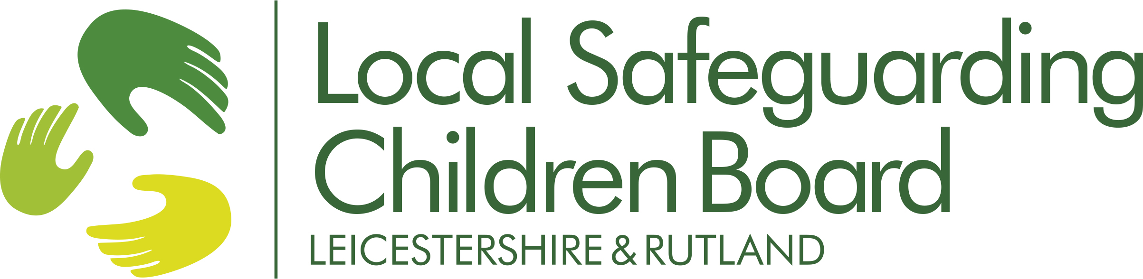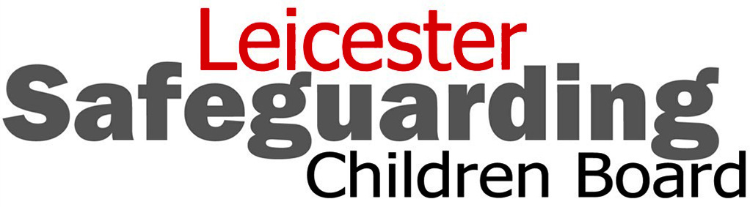
Letter for licensed businesses
Mr Smith
Business owner
Business name
Business address
Business town
Postcode

Dear Mr Smith
Licensing Act 2003: Protecting children from harm
DID YOU KNOW … Under the Licensing Act of 2003, one of the licensing objectives is to ‘protect children from harm’. This is a fundamental principle and steps should be taken to uphold this objective and to actively promote it.

The leaflet ‘child sexual exploitation - could you spot the signs?’ for businesses
- draws attention to the responsibilities of premises owners with regards to ‘protecting children from harm’
- outlines the signs of child sexual exploitation
- outlines six ‘protection steps’ which should be incorporated into a licensed business and used for staff training with the aim of protecting
- young people
- and your business
- contains useful contact details – emergency / support / for more information.
For further information please contact your licensing officer, Leicestershire Police or Leicester, Leicestershire and Rutland Safeguarding Children Boards www.lcitylscb.org or www.lrsb.org.uk
Kind regards

Jane Green
Licensing Officer, Xxxx xxxxxx District Council
